Site Reliability Engineer Assessment

1. I will check the naming convention, the source control for CI and check if there is any static code analysis implemented. In my experience, having static code analysis can help a lot in the long run. After checking the CI, I will move to check the CD, need to check how many environments and any pre-approval or manual deployment implemented. For lower environment like development, we want to make it as smooth as possible so development team can build and test faster.
2. SOP way in here means like collection of troubleshoot fix. 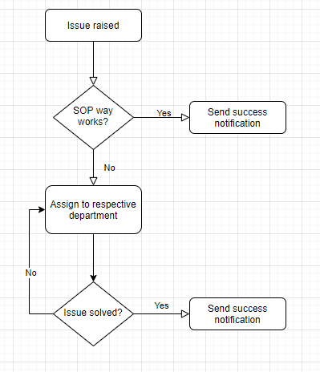
3. There are 2 ways to scale, vertical and horizontal. It depends on how complex the system. Horizontal meaning adding more compute power and vertical means higher size or upgrade.
4. By implementing monitoring tools, can be 3rd party or native from cloud computing provider. Configure alert and notification to send incident to respective people or groups.
5. SLA is formal agreement between client and providers for specific metrics. SLO is customer expectation or goal that service provider wants to reach. SLO is important because it’s directly impacting client satisfaction, it’s kind of fulfilling promise to client.
6. White box is monitoring applications running on server and black box is monitoring on server metrics(e.g CPU usage, memory usage, disk space).
7. For AWS, we can use AWS cloudwatch to gives detail operational visibility for each instances, log API calls with AWS cloudtrail. For EC2, it is important to monitor CPU usage, memory usage and disk space. It’s important to put alert if it hits certain number, for example if it hits above 70% of CPU usage, send email or push notification to group of users. If requires, we can use eventbridge to automatically respond to system events.
8. See in attachment(brick test.drawio or brick test.jpg)
9. There is a problem when we want to deploy the code, sometimes get error and can’t deploy. We identify the issue because of number of applications running and cpu usage. Even though our autoscaling running, it’s not capable of handling our big number of applications. We don’t get this issue previously, we suspect because the cloud provider become more strict about this. Our solution is vertical scaling and have horizontal autoscaling.
10. a. Provide how to or tutorial everywhere.   
    This is good practice especially for new onboarding member.

b. Eliminate night shift  
It is good practice to have team across different geography so there is no night shift. It’s important for long term efficiency and employee’s stress level.

c. Structure Standard of Procedure

Having clear instruction how to act and who to ask or where to escalate is priority for on call situation.

d. Review regularly

Do regular review to create collections of solution according to raised incident and if possible, minimize future issue by fixing the code, add new validation, or changing the user interface.